|  |  |  |
| --- | --- | --- |
| User Manual | April 1  2013 | |
| Image Correlation Spectroscopy (ICS) is an application for performing analysis on images of bio-membranes taken from microscopes. It is capable of completing correlations between different image channels, which are then used to output graphs and values. The application consists of two parts: a standalone executable for Windows and Linux, and a web interface which can be set up on a web server and accessed remotely.  Developed for Dr. Nils Petersen at the University of Alberta as a project for CMPUT 401 in Winter 2013.  Copyright © 2013 Nick Klose, Richard Leung, Cameron Mann, Glen Nelson, Omar Qadri, and James Wang. | | ICS: Image Correlation Spectroscopy |

Table of Contents

Introduction 2

Local GUI 3

Overview 3

Components 3

Single Image Mode 6

Batch Mode 7

Graph Zoom Interface 7

Help/About Interface 7

Installation 7

Linux/UNIX 7

Windows 8

Single-Image Mode 8

Loading Images 8

Auto-Correlations 9

Cross-Correlations 9

Triple-Correlations 9

All Correlations 9

Exporting Results 9

Batch Mode 10

Help/About Dialog 10

Sample User Scenarios 11

User Scenario #1 11

User Scenario #2 12

User Scenario #3 13

Web GUI 15

Overview 15

Single-Image Mode 15

Overview 15

Loading Images 15

Correlation Processing 15

Batch Mode 16

Screenshots 17

Auto-Correlations Parameters 17

All Correlations Parameters 17

Batch Configuration 18

Delete Batch Confirmation 18

Other Information 18

Input Parameters 18

Supported File Extensions 19

Batch File Naming Convention 19

Miscellaneous Notes 20

# Introduction

Image Correlation Spectroscopy (ICS) is an application for performing analysis on images of bio-membranes taken from microscopes. It is capable of completing correlations between different image channels, which are then used to output graphs and values. The application consists of two parts: a standalone executable for Windows and Linux, and a web interface which can be set up on a web server and accessed remotely.

The local user interface is downloaded and installed as an executable packaged with all dependencies. It consists of Single-Image Mode, which can run specific correlations on a single RGB image (or a set of 3 monochrome images), and Batch Mode, which is capable of running all possible correlations on an arbitrarily large set of images. Results for either mode can be exported in the form of graph images and text files.

The web interface essentially delivers the same functionality as the downloadable executable, with a few extra features including an administrative approval-based account registration system. Due to the overhead of uploading large sets of images, the web interface performs correlations only on a single RGB image or a set of 3 monochrome images.

Both interfaces feature Single-Image Mode and Batch Mode.

# Local GUI

## Overview

The local GUI is a standalone, cross-platform application consisting of separate interfaces for Single-Image Mode and Batch Mode, as well as a Help interface and Graph Zoom interface.

## Components

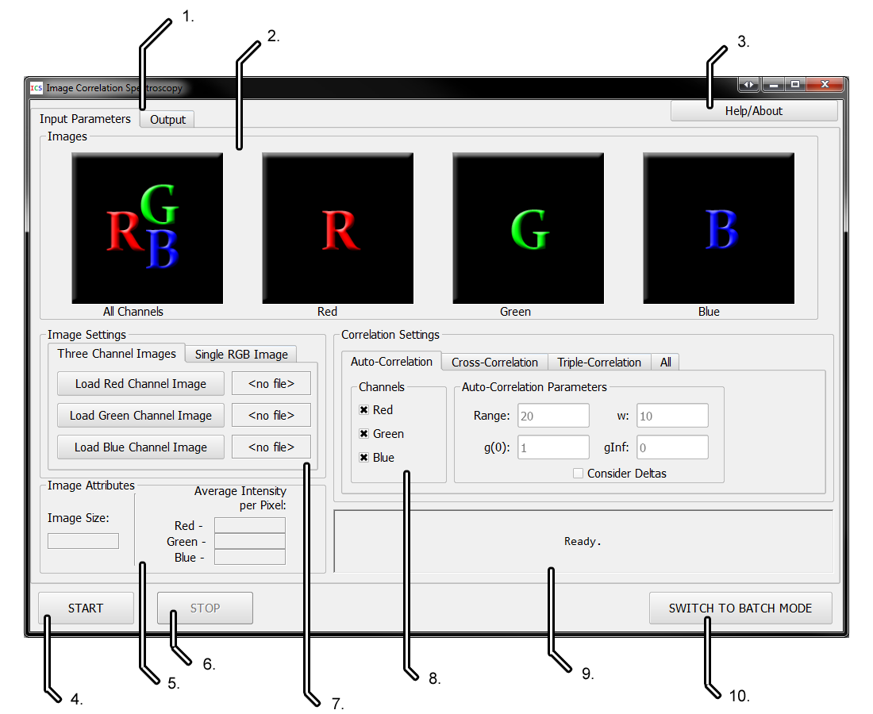

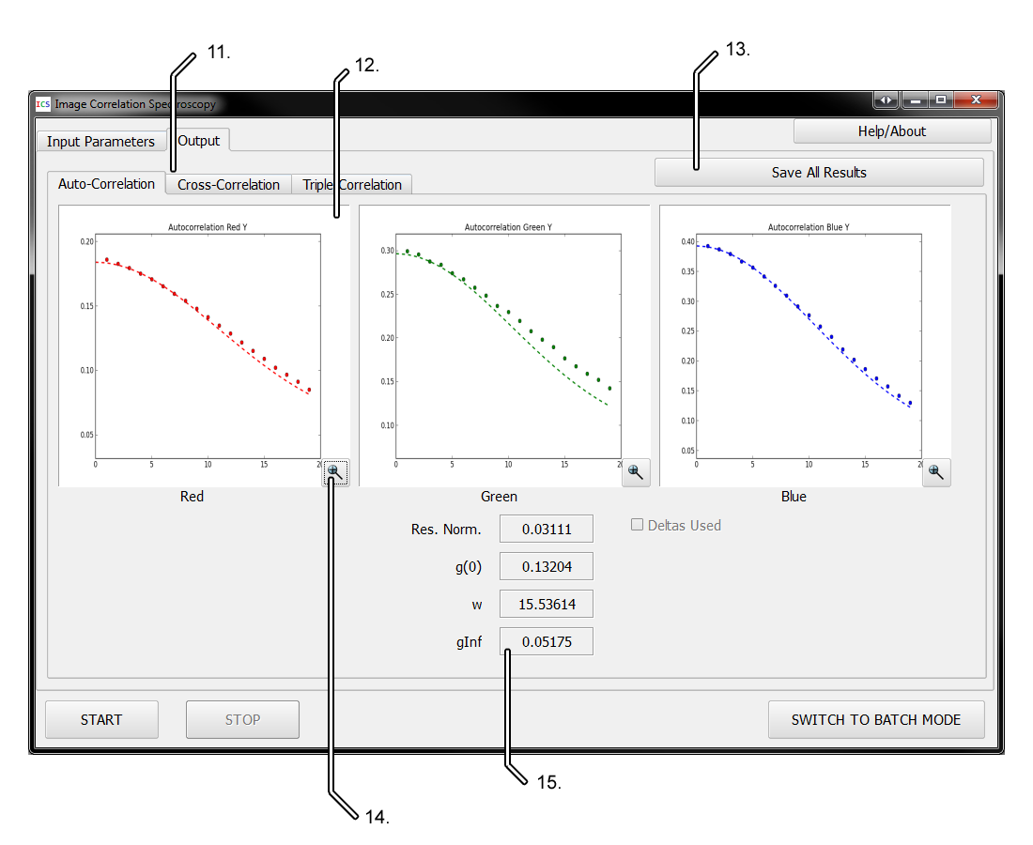

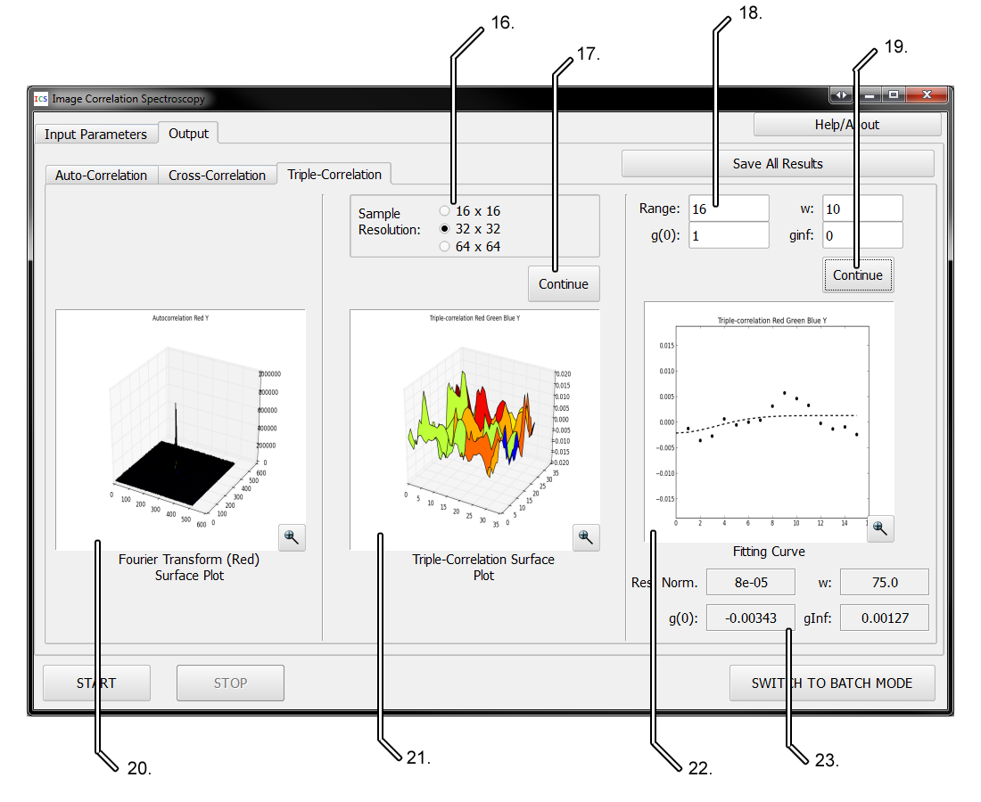

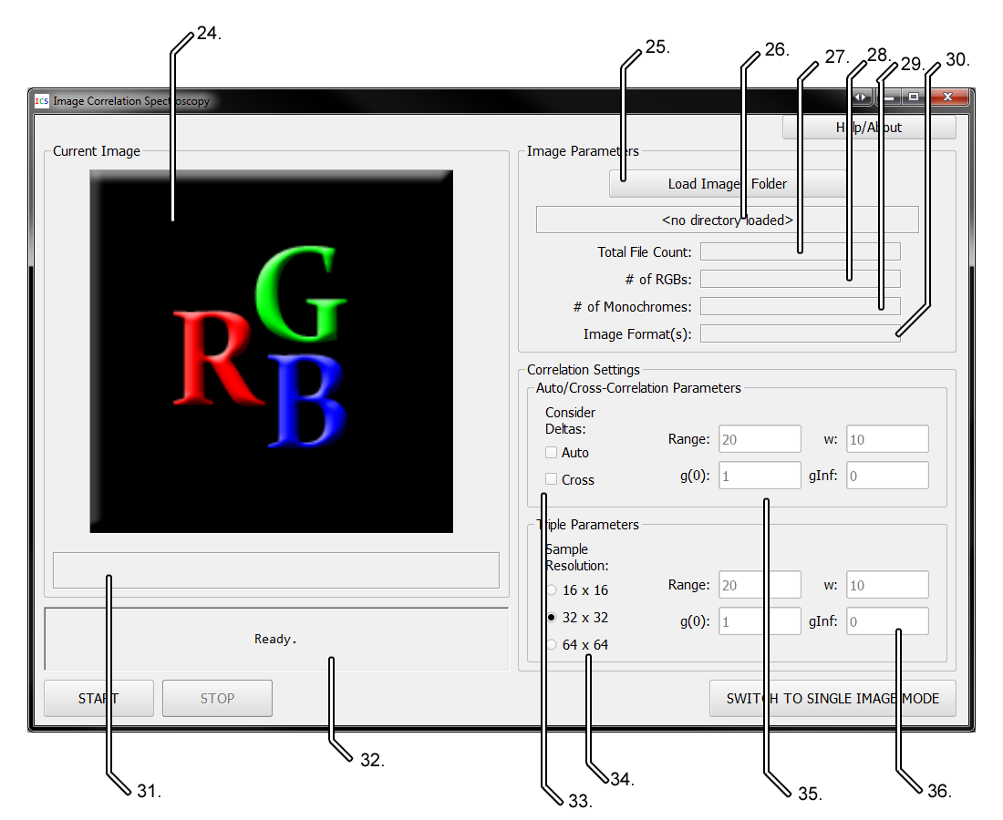

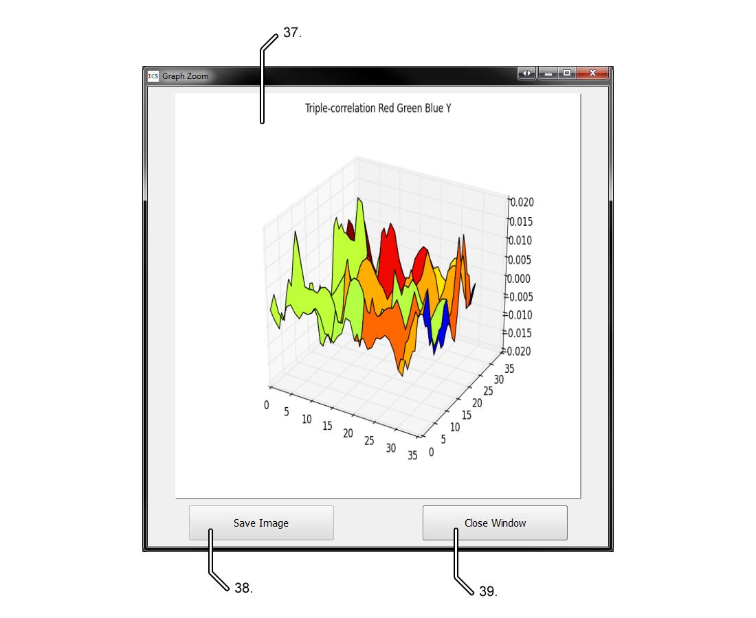

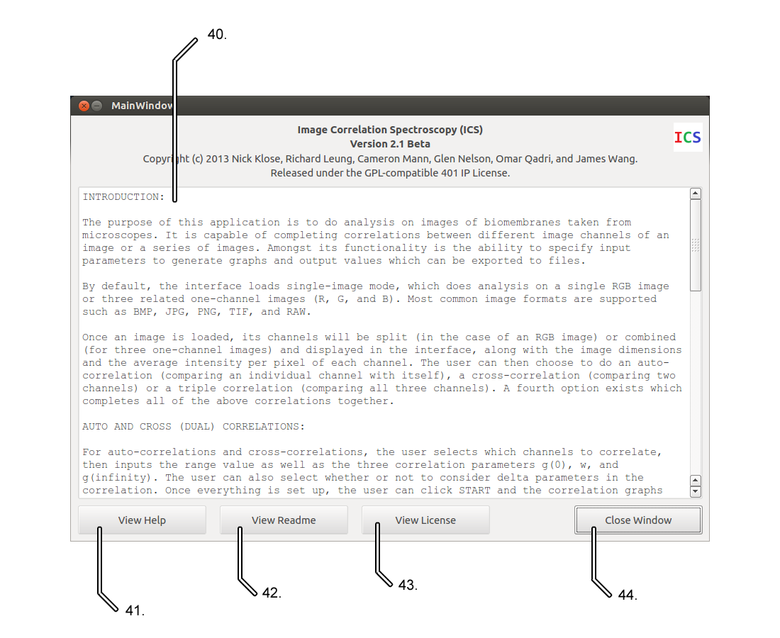

### Single Image Mode

1. Input/Output Tab Selector
2. Channel Images
3. Help/About Button
4. Start Button
5. Image Attributes Section
6. Stop Button
7. Image Loader
8. Correlation Settings Section
9. Message Box
10. Batch Mode Switching Button
11. Output Sub-Tab Selector
12. Dual-Correlation Graphs
13. Export Results Button
14. Zoom Button
15. Dual-Correlation Output Values
16. Sample Resolution (Limit) Selector
17. Triple Correlation Continue Button #1
18. Triple Correlation Input Parameters
19. Triple Correlation Continue Button #2
20. Triple Correlation Surface Plot of Fourier Transform of Red Channel
21. Triple Correlation Surface Plot
22. Triple Correlation Fitting Curve
23. Triple Correlation Output Values

Not shown: progress bar (only displayed while processing).

### Batch Mode

1. Current Image Preview
2. Directory Selector
3. Current Directory Path
4. Directory File Count
5. Directory RGB Image Count
6. Directory Monochrome Image Count
7. Directory Image Format List
8. Current Image Path
9. Message Box
10. Consider Deltas Checkboxes
11. Sample Resolution (Limit) Selector
12. Dual Correlation Input Parameters
13. Triple Correlation Input Parameters

Not shown: progress bar (only displayed while processing).

### Graph Zoom Interface

1. Graph Preview
2. Graph Save Button
3. Close Button

### Help/About Interface

1. Text File Preview
2. Help File Selector
3. Readme File Selector
4. License File Selector
5. Close Button

## Installation

### Linux/UNIX

For Linux/UNIX, the source must be compiled.

1. Install cx-freeze using **sudo apt-get install cx-freeze**
2. Edit **/usr/lib/pymodules/python2.7/cx_Freeze/finder.py**. On line 232, change   
   **path = parentModule.path**   
   to   
   **path = parentModule.path or parentModule.file**
3. Find the mpl-data directory (probably at /usr/share/matplotlib/mpl-data)
4. Make a link using  
   **sudo ln –s /usr/share/matplotlib/mpl-data /usr/lib/pymodules/python2.7/matplotlib/mpl-data**
5. Fix any broken links.
6. Run the makefile.
7. Distribute the binary.

### Windows

Our application provides a Windows installer for easy set-up.

1. Run the provided setup.exe. While it is running, complete the following steps.
2. If the Microsoft Visual C++ 2008 Redistributable setup begins, install it.
3. When the ImageMagick installer starts, install it unless it is already installed on your machine. Do not install ImageMagick if you already have it.
4. Run the Image Correlation Spectroscopy interface from the Start menu.

## Single-Image Mode

Single-image mode allows the user to perform a correlation or set of correlations on a single image or a set of 3 monochrome images.

It consists of an Input tab and an Output tab. Input parameters and images are inputted in the input tab, and output data is shown in the Output tab. An exception to this is the triple-correlation, in which case the user will input some data in the output tab during the correlation process.

### Loading Images

Images can be loaded either as a single RGB image or as a set of 3 monochrome images.

To load a single RGB image, choose the “Single RGB Image” tab and click the “Load RGB Image” button.

To load 3 monochrome images, choose the “Three Channel Images” tab and click each of the load channel buttons.

As soon as an image is loaded, it will be displayed in the Images section above the appropriate channel label. If the image is an RGB image, it will be split into the three channels which will be displayed. If the image consists of three monochrome images, they will be merged and shown above the All Channels label.

Even though loaded monochrome images are stored in grayscale, they will show up in the interface as their proper color. This is only for the purpose of displaying the image and is not used in correlations.

Once an image or image set has been loaded into the interface, the size in pixels will be shown in the Image Attributes section, along with the average intensity per pixel of each channel.

### Auto-Correlations

Auto-correlations correlate an image channel with itself.

To perform an auto-correlation, load an image or image set and choose the “Auto-Correlation” tab. Select which channels to correlate by checking off the checkboxes under the Channels label. Note that at least one channel must be selected to perform the correlation. To consider deltas during the correlation, check off the “Consider Deltas” checkbox. Press the Start button once the image and parameters have been set. If there are any input errors, they will be displayed in the message box. Otherwise, the interface will automatically switch to the Auto-Correlation sub-tab of the Output tab and display the selected graphs and all output values.

### Cross-Correlations

Cross-correlations correlate two image channels together.

Cross-correlations are carried out the same way as auto-correlations, except that the user must select the “Cross-Correlation” tab and input parameters there. Additionally, the user selects pairs of channels to correlate together rather than single channels.

### Triple-Correlations

Triple-correlations correlate all image channels together.

Because of the procedural nature of triple correlations, there are no initial settings other than selecting the image to correlate. To perform a triple-correlation, select the “Triple-Correlation” tab and press the Start button. The interface will automatically select the “Triple-Correlation” sub-tab of the Output tab and display the surface plot of the Fourier transform of the red channel. The user can then select a sample resolution (limit) to use, and press the first Continue button. The triple-correlation surface plot will then be calculated and displayed, and the user can input a range and set of fitting parameters based on this. When the user clicks the second Continue button, the fitting curve and output values are displayed and the process is complete.

Note that if the user wishes to revise the selected sample resolution or inputted values, he/she can do so by changing the value(s) and pressing the Continue button again.

### All Correlations

The user may wish to perform all possible correlations on an image.

To perform all correlations, choose the “All” tab and input the range and fitting parameters for the dual- (auto- and cross-) correlations, then press the Start button. Upon pressing Start, the Auto-Correlation and Cross-Correlation sub-tabs of the Output tab will be updated with graphs and output values, and the interface will automatically select the Triple-Correlation sub-tab to begin the triple-correlation process.

### Exporting Results

To export a single graph, press the Zoom button for that graph, click the Save Image button, and select a directory to save the graph into. Graphs are always saved as .PNG images.

To export all graphs and output values, press the Save All Results button and select the directory to output to.

## Batch Mode

Batch mode allows the user to perform correlations on an arbitrarily large directory of images.

Images in a batch mode input directory must follow the appropriate naming convention. See the “Batch File Naming Convention” section for more details.

Images (or other files or directories) in an input directory which do not follow the naming convention will be ignored.

Unlike Single-Image Mode, the user cannot select specific channels or correlations to perform. However, the user can input separate parameter sets for dual- (auto- and cross-) and triple-correlations, as well as whether to use deltas for each dual correlation and the sample resolution (limit) to use for the triple-correlation.

Batch correlations can be performed on single RGB images, sets of monochrome images, or both. The only constraints are that all RGB images must be of a consistent format, and likewise for monochrome images. It is fine for the monochrome images to be in a different format from the RGB images. Additionally, all files must follow the batch file naming convention to be considered for the correlation.

To perform a batch correlation, press the “SWITCH TO BATCH MODE” button in the Single-Image Mode, then press the “Load Images Folder” button to select an input directory. Input the correlation parameters, then press the Start button. The interface will display the image being processed currently, as well as its file path. The message box will show how many correlations in the current set have been completed, and the progress bar will give the user an idea of how much progress has been made so far.

At any time during the correlation process, the user can interrupt the process by clicking the Stop button.

## Help/About Dialog

The Help/About dialog acts as a text file viewer for files relevant to the application. Specifically, it allows the user to view the HELP, README.md, and LICENSE files from the program’s installation directory.

To open the Help/About dialog, press the Help/About button in either program mode.

To view a specific file, press its view button at the bottom of the interface.

Note that these files can be modified with a text editor and the changes will be reflected in this interface. The first four lines of the HELP file are special as they become the header for this interface. The first line is the program title, the second is the version, the third is the copyright information, and the fourth is the license information. The fifth line of the file is ignored, and the rest of the file is shown in the text viewer.

## Sample User Scenarios

### User Scenario #1

A user would like to perform a cross-correlation on an RGB bio-membrane image using only the red-green and green-blue channel pairs. The user wants the correlation to be processed using a range of 10, a g(0) of 1, a w of 10, and a g(infinity) of 0. The user wants deltas to be considered in the correlation.

1. The user loads the ICS executable.
2. The user clicks on the “Single RGB Image” tab.
3. The user clicks the “Load RGB Image” button, and selects the image using their operating system’s file browser. The image and its three separate channels are shown in the “Images” section of the interface. The “Image Size” is updated, and the “Average Intensity per Pixel” values are shown. The message box informs the user that their image has been loaded.
4. The user selects the “Cross-Correlation” tab.
5. The user unchecks the “Red-Blue” checkbox.
6. The user inputs 20, 1, 10, and 0 respectively into the Range, g(0), w, and gInf textboxes.
7. The user checks off the “Consider Deltas” checkbox.
8. The user clicks the start button. The progress bar fills up as the correlation is computed, and the message box is updated confirming the inputted parameters. The interface automatically selects the “Cross-Correlation” sub-tab in the “Output” tab of the interface and displays the Red-Green and Green-Blue correlation graphs, as well as the calculated values for Res. Norm., g(0), w, and gInf. The interface shows whether deltas were used in the correlation.
9. The user notes that the Green-Blue curve does not match the data well, and clicks on the “Input Parameters” tab to modify the inputted parameters.
10. The user clicks Start once more, and the graphs and output values are updated.
11. The user clicks on the Zoom button for the Red-Green graph, causing the Graph Zoom window to appear.
12. The user clicks the “Save Image” button to save the graph to a specified directory.
13. The user clicks the “Close Window” button to dismiss the Graph Zoom dialog.
14. The user closes the interface.

### User Scenario #2

A user would like to perform a triple-correlation using three separate monochrome images for each channel of a bio-membrane image. The user is uncertain of what range, fitting parameters, or sample resolution they would like to use.

1. The user loads the ICS executable.
2. The user presses the “Help/About” button to learn more about the application. The Help/About dialog appears.
3. The user reads the help file and closes the dialog.
4. The user clicks the “Load Red Channel Image” button and selects the red channel image using their operating system’s file browser. The red image is displayed above the “Red” label in the “Images” section.
5. The user does the same for the red and blue images using the “Load Green Channel Image” and “Load Blue Channel Image” buttons. Once the user loads the blue image, the combined RGB image is shown above the “All Channels” label in the “Images” section.
6. The user realizes he/she selected the wrong file for the green channel image, and clicks the “Load Green Channel Image” button to select a different file. The “All Channels” image updates accordingly.
7. The user selects the “Triple-Correlation” tab.
8. The user clicks the “Start” button. The “Triple-Correlation” sub-tab of the “Output” tab is selected automatically. The surface plot for the Fourier Transform using the red channel is displayed.
9. The user clicks the “Zoom” button to get a closer look and decide on a sample resolution to use. The Graph Zoom window shows a larger version of the graph.
10. The user clicks the “Close Window” button to dismiss the Graph Zoom window.
11. The user selects a sample resolution of 16 x 16 based on the graph using the radio buttons.
12. The user clicks the first Continue button, and the triple-correlation surface plot is displayed. The user decides on range, g(0), w, and g(infinity) values to use based on this graph.
13. The user inputs 20, 10, 5, and 0 respectively into the Range, g(0), w, and ginf textboxes.
14. The user clicks the Continue button. The interface recognizes that the user has made an invalid choice by inputting a range greater than the selected sample resolution. The user’s inputted range value is cleared, and the interface focuses on that window to allow the user to input a different value.
15. The user inputs 15 for the new range value, and clicks the second Continue button. The fitting curve and output values for Res. Norm., g(0), w, and gInf are displayed.
16. The user decides to change the g(0) parameter to 12, then clicks the second Continue button again. The fitting curve and output values update accordingly.
17. The user presses the “Save All Results” button and selects a folder to output the correlation graphs and values to.
18. The user closes the interface.

### User Scenario #3

A user would like to perform all possible correlations on an RGB image. The user would like to use a range of 27.5, a g(0) of 5, a w of 0, and a gInf of 10 for the auto- and cross-correlations. For the triple correlation, the user would like to use a sample resolution of 32 x 32 and a range of 30 but is unsure of what fitting parameters to use.

1. The user loads the ICS executable.
2. The user clicks on the “Single RGB Image” tab.
3. The user clicks the “Load RGB Image” button, and selects the image using their operating system’s file browser. The image and its three separate channels are shown in the “Images” section of the interface. The “Image Size” is updated, and the “Average Intensity per Pixel” values are shown. The message box informs the user that their image has been loaded.
4. The user selects the “All” tab.
5. The user unchecks the “Red-Blue” checkbox.
6. The user inputs 27.5, 5, 0, and 10 respectively into the Range, g(0), w, and gInf textboxes.
7. The user clicks the Start button. The message box informs the user that the value for w must be greater than 0.
8. The user changes their inputted value for w to 5, but accidentally holds down the Shift key and inputs a % sign instead.
9. The user clicks Start again. The message box informs the user that the value for W must be a number.
10. The user corrects their mistake and inputs a w value of 5.
11. The user clicks Start again. The message box informs the user that they must use an integer range.
12. The user changes their inputted Range to 27.
13. The user clicks start. The auto- and cross-correlations are computed, and the graphs and output values are shown on the “Auto-Correlation” and “Cross-Correlation” sub-tabs of the “Output” tab. The interface automatically loads the “Triple-Correlation” sub-tab and displays the surface plot of the Fourier Transform using the red channel.
14. The user selects a sample resolution of 32 x 32 and clicks the first Continue button. The triple-correlation surface plot is displayed.
15. The user changes his/her mind and decides instead to use a sample resolution of 64 x 64. The user selects this using the radio buttons and clicks the first Continue button again. The triple-correlation surface plot is updated.
16. The user inputs a Range of 30 and decides on fitting parameters g(0)=10, w=10, and ginf=5 based on the displayed graphs.
17. The user clicks the second Continue button. The interface displays the fitting curve and output values.
18. The user closes the interface.

**User Scenario #4**

A user would like to perform all possible correlations on a set of images using (range=20, g(0)=1, w=10, g(infinity)=0) in all cases. Some images are RGB and some are monochrome. The user would like to consider deltas for auto-correlations but not for cross-correlations, and would like to use a sample resolution of 64 x 64.

1. The user ensures that the images to be correlated are all in the same folder and follow the batch file naming convention.
2. The user loads the ICS executable.
3. The user clicks “SWITCH TO BATCH MODE”.
4. The user clicks the “Load Images Folder” button and selects the folder using their operating system’s file browser.
5. The user checks off the “Auto” checkbox under the “Consider Deltas” heading in the “Auto/Cross-Correlation Parameters” section.
6. The user selects a sample resolution of 64 x 64 for triple correlations using the radio buttons.
7. The user inputs 20, 1, 10, and 0 respectively in the textboxes for range, g(0), w, and gInf.
8. The user clicks the Start button. The batch correlation process begins. As each image is correlated, it is shown in the interface.
9. The user realizes a range of 30 would be better, and presses the Stop button.
10. The user makes the change and presses Start. The correlation is performed on all images, and the output data is added into a folder in the same directory as the input folder, with the original folder name plus a “_output” suffix.
11. The user closes the interface.

# Web GUI

## Overview

The Web GUI, when running on a server, allows users to perform image correlations remotely via their web browser.

A registered account is required to access the ICS functionality using the web interface.

On the signup page, users need to create a username and password for authentication into the site as well as provide a valid email address. Upon clicking the submit button the user will be sent an email confirmation as well as an account activation key (URL-based) to the email they provided. Once the account is successfully activated the user should see a confirmation similar to what’s shown below.

## Single-Image Mode

### Overview

To run a single correlation using web interface first by clicking on Single Mode on the navigation bar on the top of the page. In Single Mode the two tabs Single Image and Separate Images presented allow the user can choose whether to upload a single RGB image or upload 3 separate monochrome images for each color channel. By clicking on the labels the user will have the option to upload either a single image or three separate images.

### Loading Images

When the blue “Upload Single Image” button is clicked, a modal dialog will pop up asking the user to specify the image file to upload. The selected image should be RGB.

When the blue “Upload Separate Images” button is clicked a modal dialog will pop up asking the user to specify the red, the green and the blue image file to upload.

The web interface allows the user to upload TIFF/TIF, PNG, BMP, or GIF files.

If the user specified and uploaded a single RGB image, the program automatically splits the images and generates the corresponding Red, Green, and Blue image channels. Otherwise, if the user specified and uploaded three separate monochrome images the program will auto generate a mixed RGB image. In addition to displaying the images, data such as image dimensions, color intensity for each channel is display to the user.

After all images have successfully uploaded and generated server side, the user is brought to a new page and will be presented with both the mixed image and three separate images for each color channel.

### Correlation Processing

Within the single mode web interface by clicking on the tabs under Correlation Settings the user can selected to perform an auto correlation, cross correlation, triple correlation, or all three correlation at once. The message in blue will tell the user which correlation the user has selected. When one of the correlation labels is clicked, a set of parameters will be displayed to the user just below the tab.

The triple correlation parameters are set sequentially. Because of the procedural nature of triple correlations, there are no initial settings. The user may just click start to begin a triple correlation. The user will notice the start button changes to ‘loading’ while the program is calculating the first Fourier Transform.

The user will notice the page will shortly change, displaying a surface plot of the Fourier transform of the red channel (i.e. Auto Correlation Red - Y Graph). After examining the graph the user then selects the resolution (limit) to which to sample the image from. Preset limits to sample from the preset 16x16, 32x32, and 64x64 and can be accessed through the drop down menu just below the surface plot. When the user has selected the limit they can press Next to continue. Once again the button will change to show loading as the Triple-correlation surface plot will then be calculated. The page will change to show the Triple-correlation surface plot and the user can input a range and set of fitting parameters based on this.

Note: If the user wishes to revise the selected sample resolution or inputted values, he/she can do so by pressing cancel which will take the user back to the Single Mode page.

Once the user has decide on the parameter he or she can press the Next button, the fitting curve and output values are displayed and the process is complete. A download button will allow the user to download the data for the fit graphs, saved graph images.

## Batch Mode

Batch Mode, which is capable of running all possible correlations on an arbitrarily large set of images. Batch allows the user to upload a ZIP containing sets of images.

Unlike Single-Image Mode, the user cannot select specific channels or correlations to perform. However, the user can input separate parameter sets for dual- (auto- and cross-) and triple-correlations, as well as whether to use deltas for each dual correlation and the sample resolution (limit) to use for the triple-correlation.

Parameters for Batch are the following:

* Image Size: The length of one side of the square input image (in pixels)
* Start at Image #: The first image to process in the batch
* Stop at Image #: The last image to process in the batch.

Completed Batch processing is stored on the server and viewable in the Batch Output Page accessed through the navigation bar.

* Clicking on the batch file allows the user to see the parameters they inputted.
* Click the Download Button to download the results of the batch.
* Delete removes the batch from the server.

## Screenshots

### Auto-Correlations Parameters

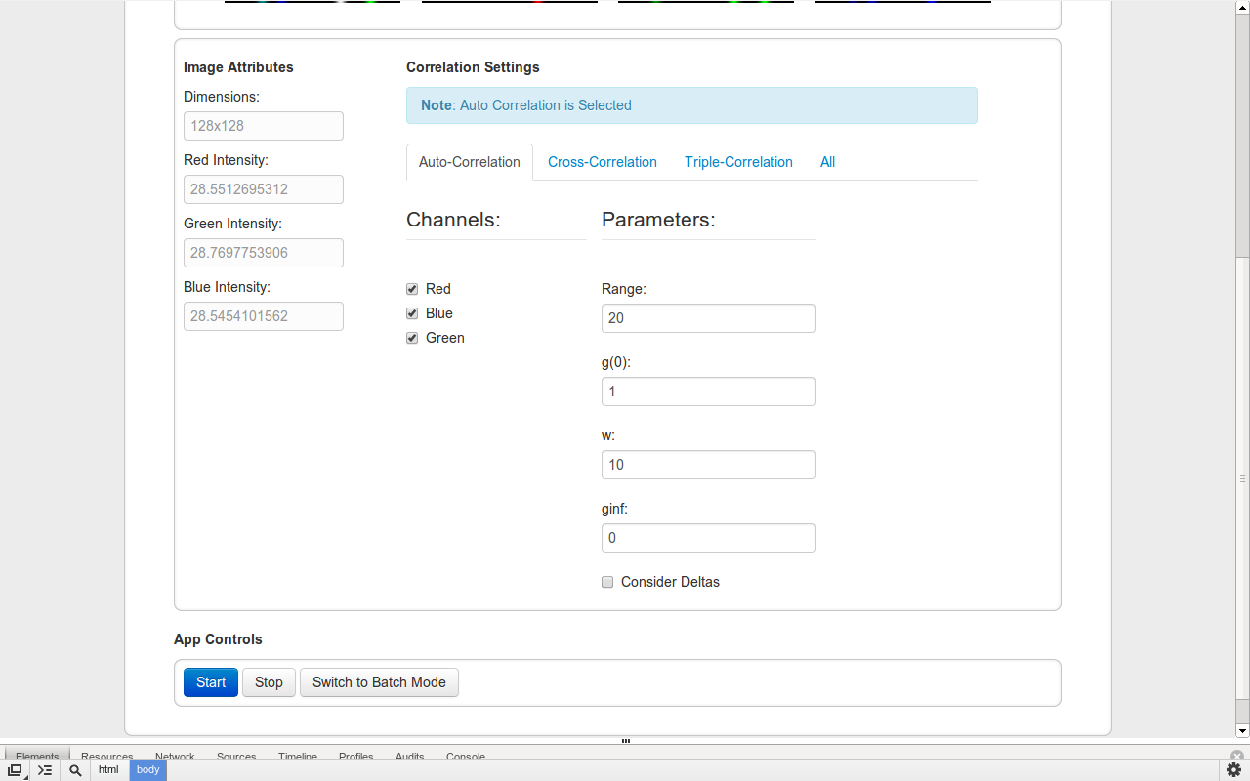

### All Correlations Parameters

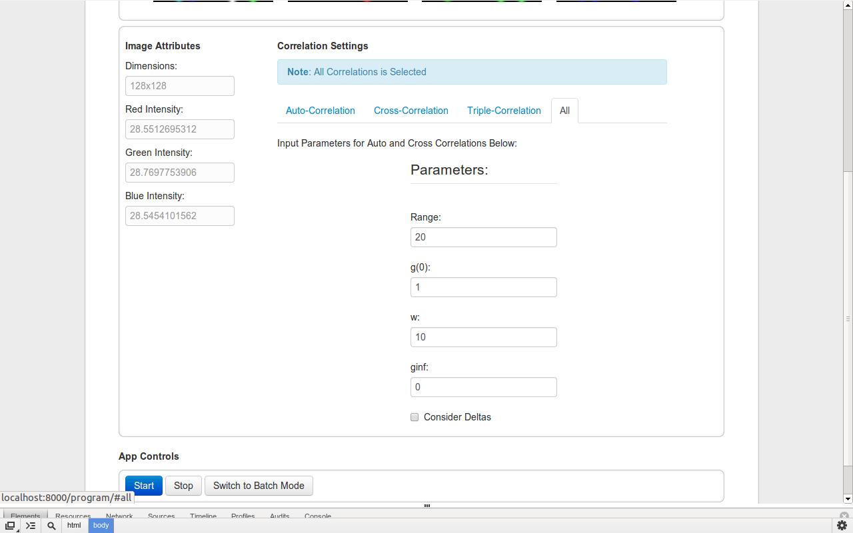

### Batch Configuration

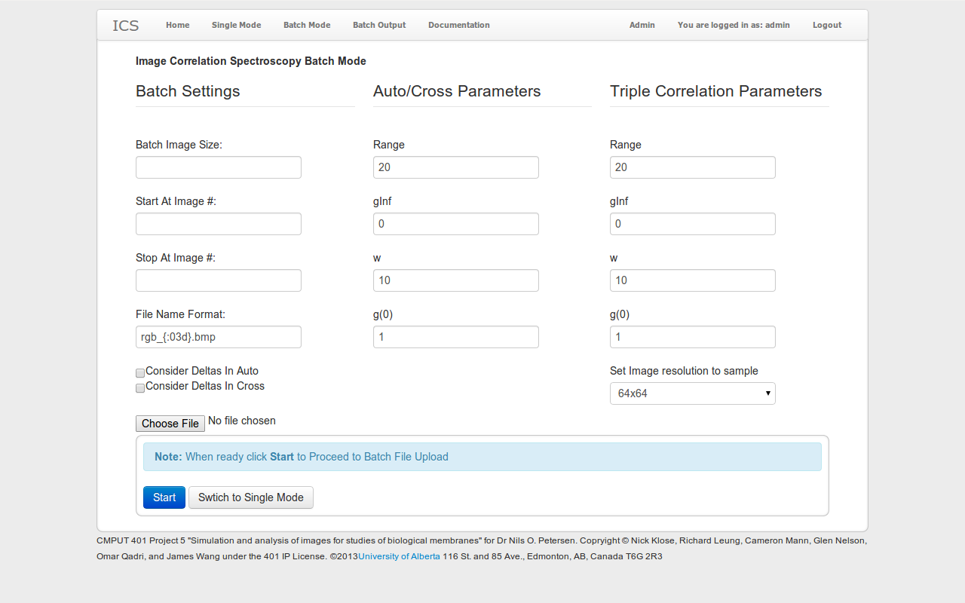

### Delete Batch Confirmation

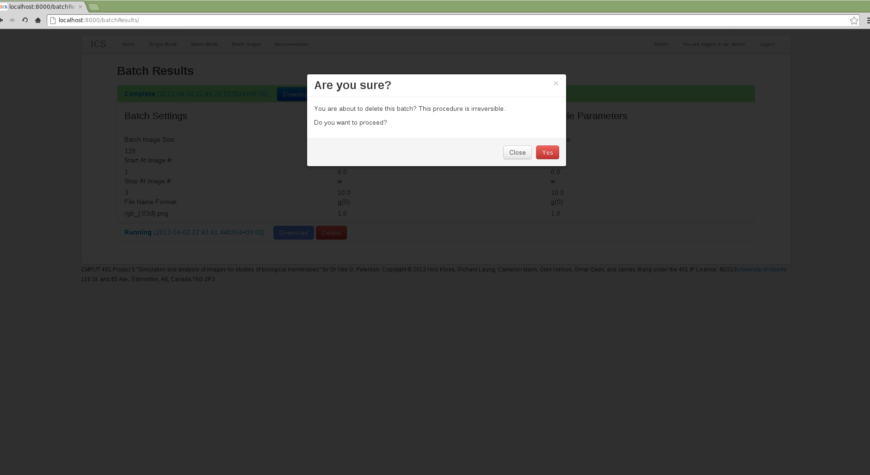

# Other Information

## Input Parameters

Correlations take four input values: range, w, g(0), and g(infinity).

**Range:** the extent of values over which to fit the Gaussian distribution.  
**g(0):** the amplitude (and the value at 0).  
**w:** the width to use.  
**g(inf):** the value at infinity.

Inputs have the following input restrictions:

* All inputs must be numeric.
* All inputs must be positive
* Range and w must be greater than 0.
* Range must be an integer.
* For triple correlations, range must be less than the sample size.

For auto- and cross-correlations, the user may specify whether to consider deltas in the correlation. The program will automatically determine which values to use. There are two deltas: the x-delta, which is horizontal displacement, and the y-delta, which is vertical displacement.

For triple-correlations, the user may specify a sample resolution to use. This is also referred to as the limit or simply the resolution. The sample resolution may be either 16 x 16, 32 x 32, or 64 x 64.

## Supported File Extensions

Image Correlation Spectroscopy supports the following file formats for input images:

* Bitmap (*.bmp)
* Portable Network Graphics (*.png)
* Tagged Image File Format (*.tif, *.tiff)
* Graphics Interchange Format (*.gif)
* Encapsulated PostScript (*.eps)

The following formats may work, but may encounter issues:

* Raw Image (*.raw)

There are known issues with running correlations on these formats, and as such they are not supported:

* Joint Photographic Experts Group (*.jpg, *.jpeg)
* Portable Document Format (*.pdf)
* Photoshop Document (*.psd)

Formats other than those listed above are not supported. However, microscope manufacturers will almost always use one of our supported formats.

## Batch File Naming Convention

Images loaded using Single Image mode can have any name. However, for Batch Mode to correctly carry out a batch of correlations, the input files must be named very specifically.

The naming convention for files in the input directory is important for the files to be read. The convention is as follows:

XXX_YYY.ZZZ

Where:

* XXX is the identifier for which channel(s) are in the image; that is, "rgb", "r", "g", or "b"
* YYY is the three-digit file number. These numbers must be sequential (e.g. 105, 106, 107...).
* ZZZ is the file extension (BMP, PNG, etc.)

The file number must be sequential, though it can start and end with any three-digit number.

The format of all RGB images must be consistent, and likewise with all monochrome images.

Each monochrome image must come in a set of 3 to make up each red, green, and blue channel. All images belonging to a set must have the same file number.

For example, the following batch sets are valid:

* rgb_001.png, rgb_002.png, rgb_003.png
* r_007.bmp, g_007.bmp, b_007.bmp, r_008.bmp, g_008.bmp, b_008.bmp
* rgb_500.tif, rgb_501.tif, rgb_502.tif, r_000.bmp, g_000.bmp, b_000.bmp

The following batch sets are *not* valid:

* rgb_001.bmp, rgb_002.bmp, rgb_004.bmp, rgb_005.bmp
* rgb_500.bmp, rgb_501.png, rgb_502.raw, rgb_503.tif
* r_001.bmp, r_002.bmp, g_003.bmp, b_003.bmp, g_004.bmp
* r_500.bmp, g_500.bmp, b_500.png

## Miscellaneous Notes

* Technically, any size of image can be used. However, the ICS application may not behave correctly if a non-square image is uploaded.
* Because of the nature of Fourier transform computations, correlations are much faster when the dimensions of an image are powers of 2 (i.e. 16 x 16, 32 x 32, 64 x 64, 128 x 128, etc.)